The Office of Acquisition and Logistics Management Newsletter

2020 4th Quarter

GSA Order Line Materials (OLMs): What You Need to Know
Have you ever tried to place a GSA Federal Supply Schedule (FSS) order, but needed some supporting items not listed on the schedule? You may have procured them as open market items using the procedures found at FAR 8.402(f). These days, you may see these types of items quoted as Order Line Materials (OLMs) and wondered how procuring products and/or services using OLM procedures differ from open market procedures.

Historically, when supporting items are not available under a schedule, it could be burdensome for ordering contracting officers (OCO) to add them to the order as open market items. The OCO had to follow all the open market acquisition regulations (publicizing, competition, contracting methods, etc.). OLMs came about to streamline the process. OLMs are purchased under authority of the FSS program under FAR 8.403(b) and GSAR subpart 538.72 – Order-level Materials.

In order to use OLM procedures, the underlying GSA contract must have the OLM SIN. OLM SINs cannot be used as a stand-alone SIN; OLM SINs only support other SINs on an order.

Let’s look at the OLM SIN description for more information about OLMs:

OLMs are supplies and/or services acquired in direct support of an individual task or delivery order placed against a Schedule contract or BPA. OLM pricing is not established at the Schedule contract or BPA level, but at the order level. Since OLMs are identified and acquired at the order level, the ordering contracting officer (OCO) is responsible for making a fair and reasonable price determination for all OLMs.

OLMs are procured under a special ordering procedure that simplifies the process for acquiring supplies and services necessary to support individual task or delivery orders placed against a Schedule contract or BPA. Using this new procedure, ancillary supplies and services not known at the time of the Schedule award may be included and priced at the order level

OLM SIN-Level Requirements/Ordering Instructions
OLMs are:
- Purchased under the authority of the FSS Program
- Unknown until an order is placed
- Defined and priced at the ordering activity level in accordance with GSAR clause 552.238-115 Special Ordering Procedures for the Acquisition of Order-Level Materials. (Price analysis for OLMs is not conducted when awarding the FSS contract or FSS BPA; therefore, GSAR 538.270 and 538.271 do not apply to OLMs)
- Only authorized for use in direct support of another awarded SIN.
- Only authorized for inclusion at the order level under a Time-and-Materials (T&M) or Labor-Hour (LH) Contract Line Item Number (CLIN)
- Subject to a Not to Exceed (NTE) ceiling price

OLMs are not:
"Open Market Items."
Items awarded under ancillary supplies/services or other direct cost (ODC) SINs (these items are defined, priced, and awarded at the FSS contract level)
OLM Pricing:
Prices for items provided under the Order-Level Materials SIN must be inclusive of the Industrial Funding Fee (IFF).
The value of OLMs in a task or delivery order, or the cumulative value of OLMs in orders against an FSS BPA awarded under an FSS contract, cannot exceed 33.33%.

Special note on Travel when using OLM procedures - Travel may be considered an OLM, however be aware that travel costs are governed by FAR 31.205-46 and:
- Do not count towards the 33.33% cost limitation
- May be a direct-reimbursable line item or may be priced on a firm fixed-price basis
- Are not subject to the IFF

Below is a table with some of the key items concerning OLMs and open market items.
Other Direct Costs (ODCs) in Support of Schedule Orders
Type | Reference | Schedule Item | Price Reasonableness Determination | Designated SIN | IFF Applies | CLIN Types Allowed
OLM | GSAR  538.72 | Yes | Ordering Activity CO | Yes | Yes | T&M/LH
Open Market | FAR 8.402(f) | No | Ordering Activity CO | No | No | All

Upcoming Training
FCL-GSA-0105 GSA Order Level Materials (OLM) | Dec. 2, 2020, 1 p.m. - 3 p.m. ET
This course will provide an overview of the authority to acquire Order-Level Materials (OLMs) under certain Federal Supply Schedule, to include implementation at the FSS solicitation, contract, and order levels. Learn how OLMs increase the flexibility of GSA Schedule to provide a total solution and reduce contract duplication-- eliminating the need to set up new commercial IDIQs or conduct open market procurements to obtain order-level Other Direct Costs. This is a two (2) CLP credit course
View the training schedule and register here: http://go.usa.gov/xEGWs.
Want to learn more? Check out these resources:
GSA Website for Order-Level Materials
GSA Training: Understanding Order-Level Materials (OLMs)
GSA Schedule Categories Authorized to Use Order Level Material (OLM) Procedures
GSA Order-Level Materials FAQs
Summary of Support Items Types for GSA Schedules Program Orders
Regulatory References
GSAR Case 2016-G506 Federal Supply Schedule, Order-Level Materials – Final Rule dated 1/24/2018
Technical Amendment to Final Rule – August 16, 2018
GSAR Clause 552.238-115 Special Ordering Procedures for the Acquisition of Order-Level Materials

Inflation Adjustment of Acquisition-Related Thresholds
Federal Acquisition Circular (FAC) 2021-01, “Federal Acquisition Regulation: Inflation Adjustment of Acquisition-Related Thresholds” became effective October 1, 2020. In summary, the DoD, GSA, and NASA have issued a final rule which amends the FAR to further implement the statute which requires an adjustment every five years of statutory acquisition-related thresholds for inflation.
The following chart identifies common threshold changes of this rule.
Threshold | Old Threshold | New Threshold | FAR Reference
MPT for Acquisitions to Support Contingency Operations or to Facilitate Defense Against Certain Attacks | $30,000 | $35,000 | 2.101, 13.201
SAT for Acquisitions to Support Contingency Operations or to Facilitate Defense Against Certain Attacks | $750,000 | $800,000 | 2.101
Simplified Procedures for Certain Commercial Items Ceiling | $7 million | $7.5 million | 12.203, 13.000, 13.003, 13.5
Simplified Procedures for Certain Commercial Items Ceiling – Emergency Declaration | $13 million for acquisitions in FAR 13.500(c) | $15 million for acquisition in FAR 13.500(c) | 13.500(c)  13.500(c)(1)

To see a full list of thresholds affected by FAC 2021-01, please visit Acquisition.gov, List of Sections Affected FAC 2021-01 Effective October 1, 2020.

NIH Small Business Program Office Hosts Second Federal Industry Day
The National Institutes of Health (NIH) provided Federal agencies with a venue to discuss future procurement opportunities with Historically Black Colleges and Universities (HBCUs) during the 2020 Federal HBCU Industry Day on September 25, 2020.

The activity, which was part of the 2020 White House Initiative on HBCUs’ virtual conference, attracted 27 HBCUs who engaged 43 agencies in matchmaking sessions. Among them were nine NIH Consolidated Operations Acquisition Centers (COACs), as well as the Department of Health and Human Services Office of Small and Disadvantaged Business Utilization (OSDBU). Participation in this year’s matchmaking event recorded a double-digit increase for both HBCUs and Federal agencies. HBCU participation grew by 69% from 2019 while representation from agencies rose 41% from 2019.

Typically, the last week of September is recognized by the White House Initiative on HBCUs as National HBCU Week and includes a conference drawing thousands of HBCU leaders and advocates to the nation’s capital. This year, because of the global pandemic, the meeting was held virtually.

Events during the last two days of the conference focused on increasing HBCUs’ competitiveness in Federal contracting. Three contracting workshops were held on September 24 and a Federal Industry Day that included matchmaking followed on September 25, 2020. During these one-on-one conversations, HBCU representatives had the opportunity to present their institutions’ technical capabilities to Federal procurement officials responsible for acquiring goods and services for the government.

The NIH Federal Industry Day’s opening session featured remarks from Dr. Michael Wooten, Administrator, Office of Federal Procurement Policy, Office of Management and Budget (OMB). Dr. Wooten discussed the potential impact of White House OMB Memorandum M-20-28, which urges agencies to leverage HBCUs. Other speakers included Diane Frasier, Head of Contracting Activity, Director Office of Acquisition and Logistics Management; and Annette Owens-Scarboro, NIH Small Business Program Manager.

“About 40% of the government’s discretionary spending goes to contracts for goods and services,” said Frasier. “In fiscal year 2019, the Federal government spent more than $560 billion in contracts.”

According to Frasier, revenue from Federal government contracts is relevant to HBCUs because “they can create more jobs on campus, which will also stimulate local economies and provide employment opportunities for students.”

“Despite the changes in the way America must conduct business in 2020, one thing has not changed: Federal agencies must continue to procure goods and services to fulfill their missions,” said Owens-Scarboro. “As the procurement forecast and acquisition plans are drafted for FY21, it is critical for Historically Black Colleges and Universities to have a seat at the table.”

Frasier and Owens-Scarboro have been working for several years to increase their agency’s engagement with HBCUs in accordance with the White House Presidential Executive Order 13779, which directs agencies to develop plans to assist in strengthening HBCUs’ ability to equitably participate in Federal programs through contracts, grants and cooperative agreements. They established the Path to Excellence and Innovation Initiative to provide outreach, training and technical assistance to HBCUs interested in pursuing contracts at the NIH and other Federal agencies.

The University of the Virgin Islands (UVI) is one of six HBCUs participating in the initiative’s pilot program. During the conference, UVI President Dr. David Hall highlighted a partnership with entrepreneur and biologist Donald Toatley. Together they developed the Safe Pass Intelligent Disinfectant Station, a science-based technology designed to mitigate the consequences of COVID-19.

(To view the video that was presented, visit: https://youtu.be/DJnBmRoKOBA)

The NIH received logistical and management support for the virtual conference from its 8(a) contractor Supreme Solutions, Inc.

The NIH will be creating new opportunities for HBCUs to increase their contracting competitiveness in the new fiscal year, so keep an eye on the agency’s website: https://oamp.od.nih.gov/content/nih-path-excellence-innovation-initiative

Photos
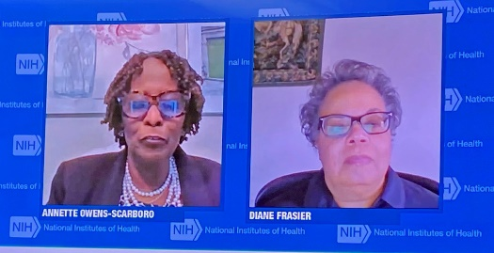
Annette Owens-Scarboro, NIH Small Business Program Manager
Diane Frasier, Head of Contracting Activity and Director of the Office of Acquisition and Logistics Management

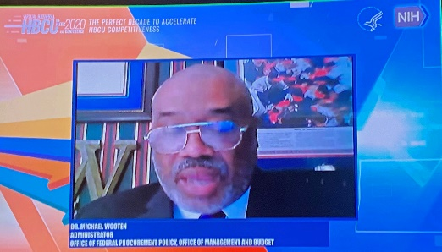
Dr. Michael Wooten, Administrator, Office of Federal Procurement Policy, Office of Management and Budget

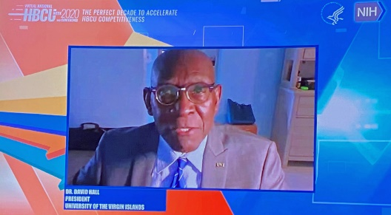
Dr. David Hall, President, University of the Virgin Islands

Receiving: Quick Reference Guide to Inspection and Acceptance
The receiving process (receipt, inspection and acceptance) is one of the most important responsibilities of a Contracting Officer. The Virtual Acquisition Office (VAO) just released a quick reference titled, “A COR’s Guide to Inspection and Acceptance.” Some definitions highlighted in this guide are the following:
- Inspection- determines the acceptability (or non-acceptability) of the services or supplies furnished by the contractor
- Acceptance- the Government’s acknowledgement that it has taken ownership of a particular contract out or product
- Unconditional Acceptance- supplies/services comply fully with the contract
- Conditional Acceptance- Government accepts supplies/services that do not conform to quality requirements or are otherwise incomplete, that the contractor is required to correct or otherwise complete by a specified date
In addition, the guide provides a flow chart of the Inspection and Acceptance Process
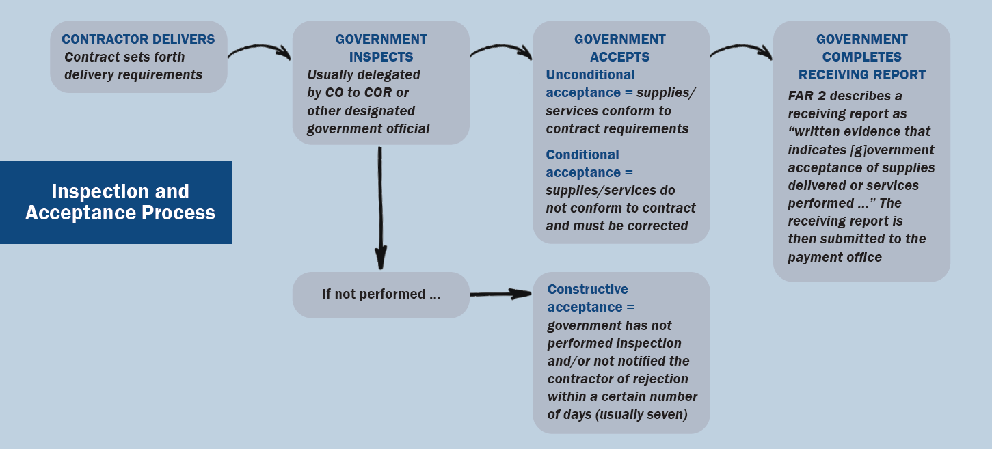
For additional information on the Receiving Process, please reference A COR’s Guide to Inspection and Acceptance or the ASRB Effective Receiving Training Presentation found on the ASRB SharePoint Site

Is Setting Up an IDIQ Right for Your Agency?
In U.S. Federal government contracting, IDIQ is an abbreviation of the term indefinite delivery/indefinite quantity. This is a type of contract that provides for an indefinite quantity of supplies or services during a fixed period. IDIQs are also sometimes called "Task" or "Delivery Order” contracts.
There are a few instances when establishing a unique agency IDIQ contract may be an appropriate business decision, especially in cases when recurring needs are anticipated. However, in most cases, an existing vehicle can fulfill an agencies’ needs. Before establishing a new agency-specific single or multiple award IDIQ vehicle, agencies should research existing vehicles and take into consideration the following:
IDIQ Contracts Require a Time Investment
Setting up an individual IDIQ contract can be both labor and time intensive. Using a GWAC gives agencies the flexibility of having their own contract without the hassle of setting it up.
Leveraging an existing vehicle does not mean you lose ownership
Many agencies set up IDIQs because they are concerned about losing ownership. With NITAAC, that is not the case. Agencies have control of their award from start to finish. Agencies write their own requirements, determine their own timeframe and, ultimately, select their own awardees, from our pool of our pre-qualified contract holders. NITAAC simply leverages our contracting expertise to help facilitate the process on the federal government’s behalf.
Realize Cost Savings
When an agency uses NITAAC, they benefit from improved pricing because our rates are pre-negotiated at the master contract level, which means they are already the lowest available rates. And, because our contracts are pre-competed, additional competition could further drive down costs at the task/delivery order level. Put simply, NITAAC allows for economies of scale in order to reduce per unit costs, which may not be possible on an individual agency contract.
Reduce timeframes and no protests under $10 million
And since time is money, agencies can reduce their timeframes by using our GWACs. On average, task orders can be awarded in 45 days or less, and delivery orders in 1-3 days. And, there are no protests under $10 million ($25 million for the DoD) if the scope, dollar value and period of performance are within the bounds of the GWAC.
Furthermore, agencies can also use GWACs to meet their small business goals under an exception to fair opportunity. And, NITAAC GWACs all carry the Best in Class designation.
IDIQs are a powerful tool in the contracting officers’ toolbox
IDIQs do have a role in federal procurement but for agencies looking to have a more streamlined procurement, or those that don’t have the time to invest in setting up their own IDIQ, NITAAC GWACs are an ideal option.

Free Acquisition Training from NITAAC
NITAAC would like to offer your agency a free training session to highlight the features and benefits of our Best in Class (BIC) Government-Wide Acquisition Contracts (GWACs) for Information Technology (IT). The session will include a program overview and a live demonstration of our ordering system, e-GOS.

NITAAC gives you a streamlined way to obtain Everything IT with our three Best in Class GWACs:
- CIO-SP3 for IT services/solutions
- CIO-SP3 Small Business for set-aside IT services/solutions and
- CIO-CS for IT commodities and commodity-enabling solutions

Anyone on your team who is involved in the IT procurement process can benefit from attending a NITAAC training session. If the dates below don’t work for you and your team’s schedule, set up a custom training by filling out a Virtual Training Request. All attendees earn two Continuous Learning Points (CLPs).

Registration Link | Date | Time
NITAAC CIO-SP3 & CIO-SP3 Small Business GWAC Training Session | Wednesday, November 18, 2020 | 10:00am – 12:00pm EST
NITAAC Monthly Training Session | Thursday, November 19, 2020 | 1:00pm – 3:00pm EST
NITAAC CIO-CS GWAC Training Session | Tuesday, December 15, 2020 | 10:00am – 12:00pm EST
NITAAC Monthly Training Session | Thursday, December 17, 2020 | 1:00pm – 3:00pm EST

In addition to training, we thought you might be interested in some of our other activities. NITAAC is here to assist you with all your IT needs. We invite you to connect with us for advanced IT planning. Contact us at 1.888.773.6542 or NITAACsupport@nih.gov.

NITAAC Virtual Industry Days
If you have an upcoming requirement, let NITAAC help you host a Virtual Industry Day. Our Contract Holders are the industry’s best at delivering innovative IT solutions, and our Best in Class GWACs make the acquisition faster and easier.

As host of a Virtual Industry Day, you’re able to put your requirements in front of an audience of Subject Matter Experts (SMEs) and get specific answers to questions you may still be considering. By starting a dialog with NITAAC Contract Holders, you may even discover solutions you never would have thought of otherwise. That’s why Industry Days are win-win for hosts and Contract Holders alike.

If you’d like to put together an event, let NITAAC show you how easy it can be. Call us at 1-888-773-6542, or send us an email at NITAAC Support today.

We look forward to working with you!
1.888.773.6542 • NITAACsupport@nih.gov • nitaac.nih.gov

Recap Corner
Below is a recap of recent OALM communications to the NIH acquisition workforce
ID | Title | Date | Purpose
20-64 | DEADLINE HAS PASSED! Resolving FY 2015 Canceling Year Lines | 8/3/2020 | Certain appropriations are available for obligation for a specific period, i.e., annual and multi-year appropriations. Both the obligated and unobligated balances of such appropriations must be cancelled and shall no longer be available for obligation or expenditure for any purpose, on September 30th of the fifth fiscal year after the expiration of an appropriation’s period of availability for incurring new obligations
20-65 | Resolving FY 2015 Canceling Year Lines | 8/10/2020 | Certain appropriations are available for obligation for a specific period, i.e., annual and multi-year appropriations. Both the obligated and unobligated balances of such appropriations must be cancelled and shall no longer be available for obligation or expenditure for any purpose, on September 30th of the fifth fiscal year after the expiration of an appropriation’s period of availability for incurring new obligations
20-66 | Are you reporting inaccurate data to the Federal Procurement Data System (FPDS)? – Unresolved FedDataCheck Alerts | 8/11/2020 | As of August 6, 2020, NIH has 1,851 unresolved FDC errors on actions reported to FPDS for FY20.
20-67 | Contractor Responsibility Assessment Automation Training with Potomac Wave | 8/12/2020 | Prohibition on Contracting for Certain Telecommunications and Video Surveillance Services or Equipment is a hot topic now. Information regarding section 889 was issued in a communication sent by the Simplified Acquisition Help Desk on Tuesday, August 11, 2020
20-68 | DEADLINE HAS PASSED! Resolving FY 2015 Canceling Year Lines | 8/17/2020 | Certain appropriations are available for obligation for a specific period, i.e., annual and multi-year appropriations. Both the obligated and unobligated balances of such appropriations must be cancelled and shall no longer be available for obligation or expenditure for any purpose, on September 30th of the fifth fiscal year after the expiration of an appropriation’s period of availability for incurring new obligations
20-69 | FPDS Scheduled Maintenance | 8/21/2020 | FPDS will be down for scheduled maintenance on Saturday, August 22, 2020, from 8:00 AM until approximately 3:00 PM (EDT). As a result, buyers will not be able to report contract actions to FPDS during this time.
20-70 | Resolving FY 2015 Canceling Year Lines | 8/24/2020 | Certain appropriations are available for obligation for a specific period, i.e., annual and multi-year appropriations. Both the obligated and unobligated balances of such appropriations must be cancelled and shall no longer be available for obligation or expenditure for any purpose, on September 30th of the fifth fiscal year after the expiration of an appropriation’s period of availability for incurring new obligations
20-71 | NIA Code - Hurricane Laura 2020 | 8/26/2020 | A new National Interest Action (NIA) value in the Federal Procurement Data System (FPDS) as a means of tracking acquisitions involved in response to Hurricane Laura 2020 is now available
20-72 | Extension of FPDS National Interest Action Code for COVID-19 | 8/28/2020 | The National Interest Action (NIA) Code for COVID-19 is being extended to continue to track acquisition costs related to the COVID-19 efforts in FPDS
20-73 | NDAA Section 889 - Link to GSA Contract Modification Tracker | 8/28/2020 | A GSA Federal Acquisition Service (FAS) 889 Part B Contract Modification Tracking Dashboard is now available to provides users with a registry of GSA/FAS managed acquisition vehicles such as Multiple Award Schedules, Government-wide Acquisition Contracts and Multiple Award Contracts along with the current 889 Part B FAR clause 52.203-25 (AUG 2020) modification status (Accepted, Declined, Waiver Approved, or Pending).
20-74 | Resolving FY 2015 Canceling Year Lines | 8/31/2020 | Certain appropriations are available for obligation for a specific period, i.e., annual and multi-year appropriations. Both the obligated and unobligated balances of such appropriations must be cancelled and shall no longer be available for obligation or expenditure for any purpose, on September 30th of the fifth fiscal year after the expiration of an appropriation’s period of availability for incurring new obligations
20-75 | Inaccurate Data in the Federal Procurement Data System (FPDS) Unresolved FedDataCheck Alerts [1,845 Actions] | 9/3/2020 | As of September 3, 2020, NIH has 1,845 unresolved FDC errors on actions reported to FPDS for FY20
20-75.1 | Inaccurate Data in the Federal Procurement Data System (FPDS) Unresolved FedDataCheck Alerts [1,845 Actions] | 9/4/2020 | This communication is to provide the correct list of unresolved FedData Check Alerts as of September 3, 2020
20-76 | Resolving FY 2015 Canceling Year Lines | 9/8/2020 | Certain appropriations are available for obligation for a specific period, i.e., annual and multi-year appropriations. Both the obligated and unobligated balances of such appropriations must be cancelled and shall no longer be available for obligation or expenditure for any purpose, on September 30th of the fifth fiscal year after the expiration of an appropriation’s period of availability for incurring new obligations
20-77 | Upcoming System Downtime – Beta.SAM.gov | 9/15/2020 | Check out the CDMP SharePoint Site for information regarding FedDataCheck Resolutions, OALM Communications, Solar Charts, Section 508, CPARS, and NBS User Account Request for Buyer-Contract and Global Receivers
20-78 | FPDS Scheduled Maintenance | 9/19/2020 | FPDS will be down for scheduled maintenance on Saturday, September 19, 2020, from 8:00, AM, until approximately 3:00 PM (EDT). As a result, buyers will not be able to report contract actions to FPDS during this time.
20-79 | FPDS ALERT – SET PIID – Contract Number Not Found – Error Message | 9/18/2020 | When creating an External Delivery/Task Order in PRISM, the Contract Number Agency ID defaults to 7529
20-80 | FPDS Alert – FedData Check Email Notifications Get You Down? | 10/7/2020 | Are you tired of receiving email notifications from Alerts@feddatacheck.net?
21-01 | FPDS Alert – FedData Check Email Notifications Get You Down? | 10/21/2020 | Are you tired of receiving email notifications from Alerts@feddatacheck.net?
21-02 | Coming Soon -- New Product Service Code Manual | 10/24/2020 | On October 24, 2020, GSA’s Integrated Award Environment (IAE) will incorporate additions and revisions to Product Service Codes (PSCs)
21-03 | FPDS Scheduled Maintenance | 10/17/2020 | FPDS will be down for scheduled maintenance on Saturday, October 17, 2020, from 8:00 AM, until approximately 3:00 PM (EDT). As a result, buyers will not be able to report contract actions to FPDS during this time.
21-04 | Reminder – FedDataCheck (FDC) Training for NIH Acquisition Staff | 10/21/2020 | Are you tired of receiving email notifications from Alerts@feddatacheck.net?
21-05 | Thank You for Attending the FedDataCheck (FDC) Training for NIH Acquisition Staff | 10/21/2020 | Thank you for attending the CDMP training session entitled “FedDataCheck (FDC) Training for NIH Acquisition Staff” presented on October 21, 2020
21-06 | FY21 FedDataCheck Data Inconsistencies as of October 23, 2020 | 10/26/2020 | Effective immediately, on a bi-weekly basis, users will receive an OALM Communication regarding data inconsistencies found in the Federal Procurement Data System – Next Generation (FPDS-NG). Please correct the errors as soon as possible.
21-07 | DEADLINE TODAY! Resolving FY 2015 Canceling Year Lines | 7/31/20 | Certain appropriations are available for obligation for a specific period, i.e., annual and multi-year appropriations. NIH’s approach is to have these lines resolved by July 31, 2020.
21-08 | DEADLINE TODAY! Resolving FY 2015 Canceling Year Lines | 7/31/20 | Certain appropriations are available for obligation for a specific period, i.e., annual and multi-year appropriations. NIH’s approach is to have these lines resolved by July 31, 2020.
21-09 | DEADLINE TODAY! Resolving FY 2015 Canceling Year Lines | 7/31/20 | Certain appropriations are available for obligation for a specific period, i.e., annual and multi-year appropriations. NIH’s approach is to have these lines resolved by July 31, 2020.
21-10 | DEADLINE TODAY! Resolving FY 2015 Canceling Year Lines | 7/31/20 | Certain appropriations are available for obligation for a specific period, i.e., annual and multi-year appropriations. NIH’s approach is to have these lines resolved by July 31, 2020.
21-11 | DEADLINE TODAY! Resolving FY 2015 Canceling Year Lines | 7/31/20 | Certain appropriations are available for obligation for a specific period, i.e., annual and multi-year appropriations. NIH’s approach is to have these lines resolved by July 31, 2020.

Acquisition Training Information

Acquisition Training at NIH
Acquisition training classes that are offered by the NIH Training Center can be accessed at the following link: Acquisitions Management Courses

Federal Acquisition Certification Coursework
CON courses and other Federal Acquisition Certification required courses can be found at the NIH Training Center, Federal Acquisition Institute, and Defense Acquisition University.
Section 508 Accessibility Training
Section 508 Accessibility Training courses can be accessed at: CIT Section 508 Accessibility Training Website.

Green Purchasing Training
Green Purchasing Training and other Green Training courses can be found at: OALM Green Purchasing Website.

NIH Blanket Purchase Agreement (BPA) Lists Available Online

Lists of all NIH Blanket Purchase Agreements (BPAs) can be found at the NIH Blanket Purchase Agreement webpage.
This location contains Two BPA Lists:
1. Complete vendor alphabetical list; and
2. Vendor list sorted by commodity.
If you have any questions or need further clarification, please contact the BPA helpline at 301-496-5212 or email.

THANKS!
We would like to thank all those who contributed to this and future editions of the OALM Newsletter.
The OALM Newsletter will be published four (4) times in calendar year 2021. We encourage staff to submit articles that would be of interest to our readers. We will do our best to include such articles in future editions of the OALM Newsletter.
Please address all correspondence to the editors: Milton Nicholas, NicholaM@od.nih.gov, Michele McDermott, McDermottMl@od.nih.gov, Jesse Lee, Jesse.Lee2@nih.gov, or Barry Solomon, SolomonBJ@od.nih.gov.
If you have any questions or comments regarding the information, policy and/or procedures published in this issue, you may contact Jesse Lee at the e-mail address above. For future editions or comments please contact the Simplified Acquisitions Helpline on 301-496-0400 or via e-mail at OALMnewsletter@mail.nih.gov and you will be referred to the appropriate editor.

